Title: EMU trilemma
Subject: EEP 16

1. The Emu Trilemma  2. The long-term way out: solving the EMU trilemma | 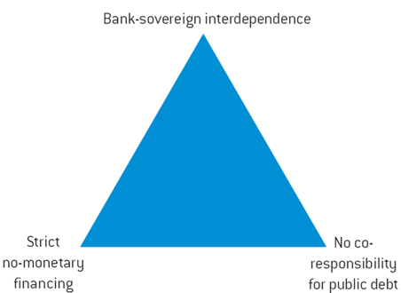  In a Monetary Union you can have just two of these things out of three:  - bank sovereign interdependence: whatever happens to commercial banks affect the gov and viceversa (IRL)  - Strict no-monetray financing:  - No co-responsibility for public debt: no bail out clase at Eu level  Situation for EMU nation before reforms  Bank sovereign interdepencence + No corresponsability for public debt (Ex. Ireland: big banks, costly bailouts).  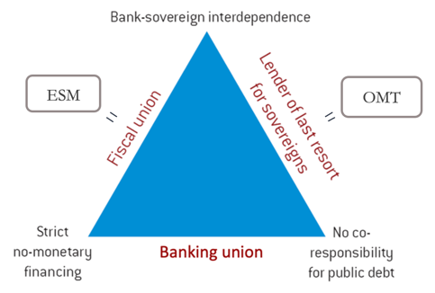  EMU has to decide which corner of the triangle it wants to cut in order to survive in the long run.  Cutting all corners = United States of Europe Eu has actually been cutting corners  Three tools/institutions developed:  - ESM: coresponsability for public debt (not enough for Fiscal Union: need shared euroepan fiscal capacity = common bonds = common expenditure (Is NextGen a one off thing?)  - OMT: monetary financing  - Banking union: bank-sovereign independence  The banking union aims at breaking the link between sovereigns and banks = minimizing taxpayer losses in case of banks resolution  There are three key pillars:  1. Single Supervisory Mechanism: a Single Rulebook on bank activities with the ECB acting as the single supervisor  2. Single Resolution Mechanism: Establishment of single court to manage the resolutions of banks and make rules respected.  There is a shift from bail out to bail in:  - During the crisis bail out: taxpayers money to save banks.  - Now there is bail in: taxpayers have nothing to do with the bank failure: 1st shareholders have to pay in, 2nd bondholders, 3rd bank funds => if this is not enough bail-out with taxpayers money. Single resolution board makes sure rules are respected.  3. European Deposit Insurance Scheme: a joint guarantee for depositors across countries.  This would reduce the vulnerability of national deposit guarantee systems to large local shocks, ensuring that the level of depositor confidence in a bank would not depend on the bank’s location and weakening the link between banks and their national sovereign: you know Eu is backing it. Not there yet.

